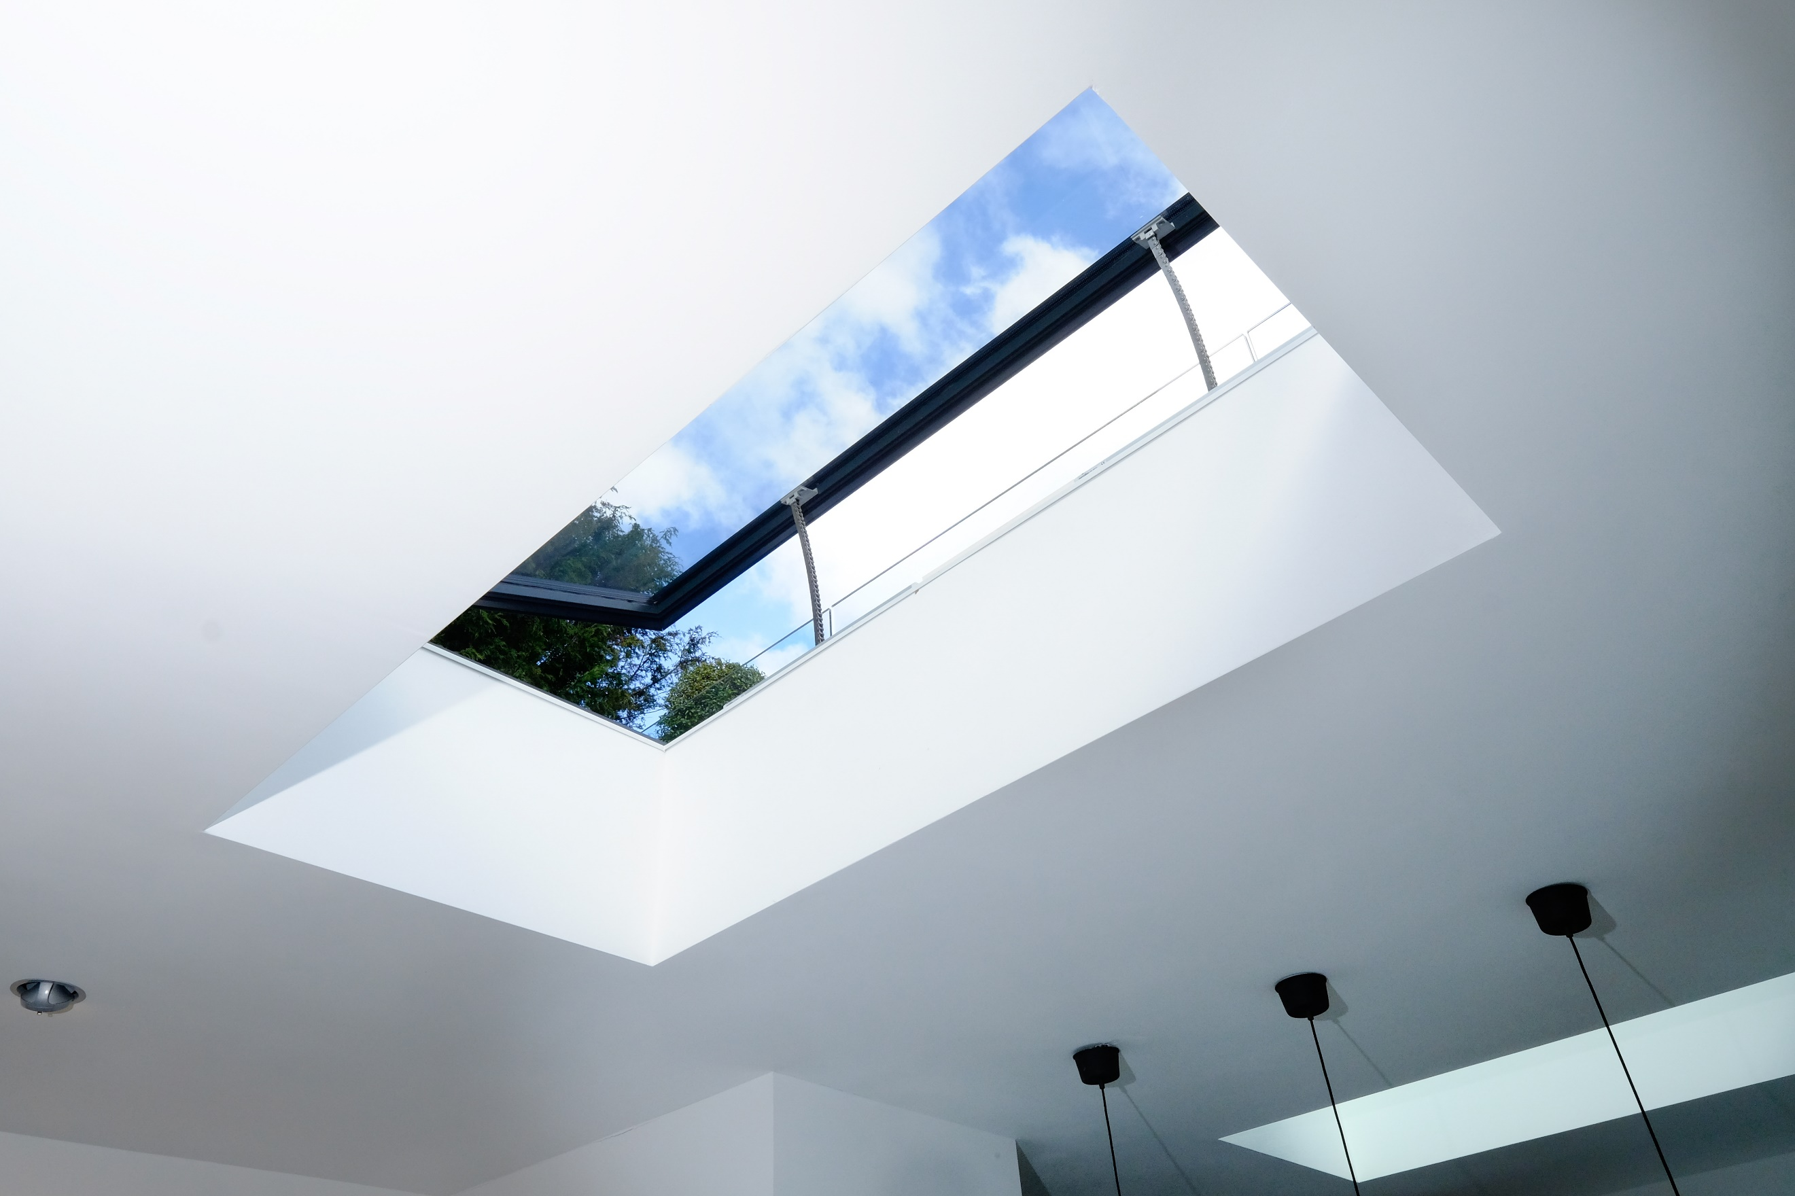  VENTING ROOFLIGHTS  NBS SPECIFICATION | HOW TO USE THIS DOCUMENT  This NBS Specification is intended as a guide. Individual project information may differ depending on the bespoke nature of the works we will be undertaking. Any element in red is where you have to insert some information. Information in blue is helpful tips for you when completing your specification.  NEED MORE HELP?  Just contact the team at IQ who will be happy to assist with your specification writing.

AUTOMATED VENTING ROOFLIGHTS
SPECIALISED AUTOMATED VENTING ROOFLIGHT SYSTEM FOR [PROJECT NAME]

LOCATION: [location of venting rooflights within the building]
Drawing reference(s): [drawing reference/number]
Manufacturer: IQ Glass UK, Sky House, Raans Road, Amersham, Bucks HP6 6JQ, Tel: 01494 722 880
Product reference: [consult IQ for specific product reference]
Item Description: [include size, configuration, location and general description]
Frame: Thermally broken aluminium framing
Colour/Finish: External powder coated RAL
Glass Specification: 6mm toughened outer, argon filled gas cavity, 13.5mm toughened laminated inner
Additional glass options: [Low Iron Glass, Low Maintenance Coatings, Solar Control Coatings, Coloured/Decorative Interlayers (available on small sizes), Acoustic Interlayer (available on small sizes), Anti Reflective Glass]
Glass Thickness:
Maximum Unit Weight:
Angle of Installation:
Kerb: Builders kerb/upstand by others
Flashings: by others
Structural Load: Maintenance Only
Opening Mechanism: [1-6]nr
Hinges: [1-6]nr
Running Voltage: [ 230V / 24V ]
Control Equipment: [SD controller and rocker switch / HD controller]
Other requirements: [Weather Sensors (rain sensors / wind sensors / temperature sensors), Portable Remote Control, Keypad, BMS Integration]
Fixing and Design: as per IQ Glass design drawings.
Size: Opening [ ]mm wide x [ ]mm long. All dimensions to be confirmed by CAD drawing.

